INFO2602 Project

Application: ‘ABCD’ Deliverables

Group: The Elite Four

* Shivam Persad - 816016854 - Marketing, UI Logic, UI Implementation, Lead
* Timothy Sookram - 816021689 - Marketing, DevOps, UI Design, UI Implementation
* Brandon Noray - 816018360 - UI Logic, UI Implementation
* Sameir Ali - 816022840 - DevOps, UI Design,UI Implementation, Server-Side Implementation

**Problem Statement:**

Often whenever you are watching movies or TV shows you lose track of what you are watching at some point due to work, social obligations or just can’t keep track of everything. What this application offers you is the ability to organize all your favourite movies and TV shows all in one place so you can finally keep track of what your watching and keep up to date with the latest media, you even have the option to rate whatever you’re currently watching with the additional feature of sorting all your favourite media by their respective genres. The application fosters an environment where users can visit to discover new/upcoming movies that they’ve yet to see whilst creating a climate where making recommendations to friends is easier than ever.  
  
**Features:**

* Register & Login functionality
* Organize movies by franchise
* Keeps track of movies watched and movies planned to watch
* Can rate movies from a scale of 1 to 10 stars
* Sort by rating and members
* Sort movies by genre

**Model Class Diagram:**  
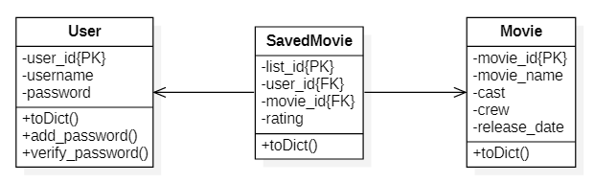

**UI Wireframe Mobile & Desktop:**  
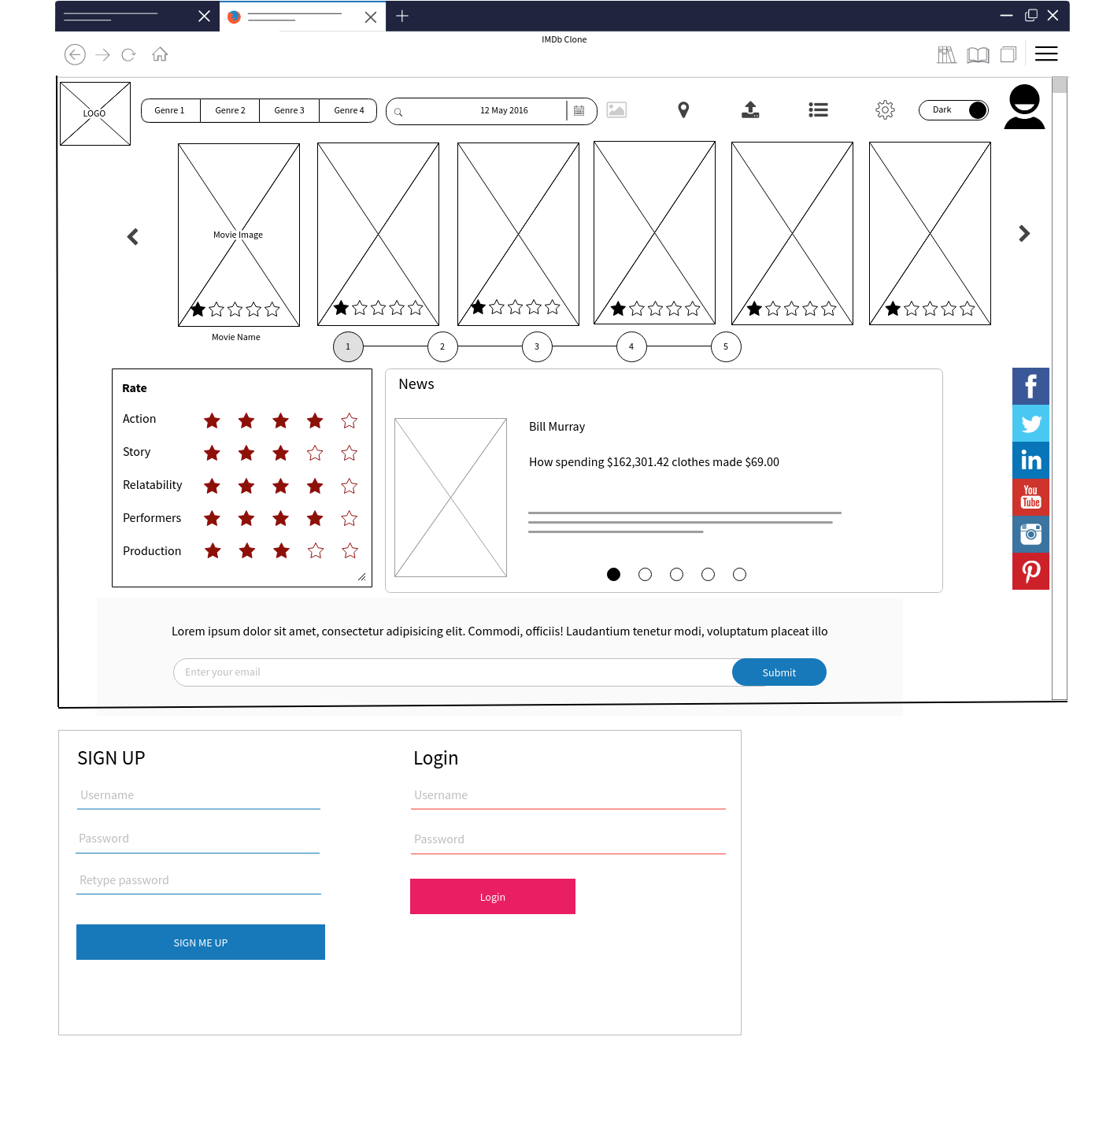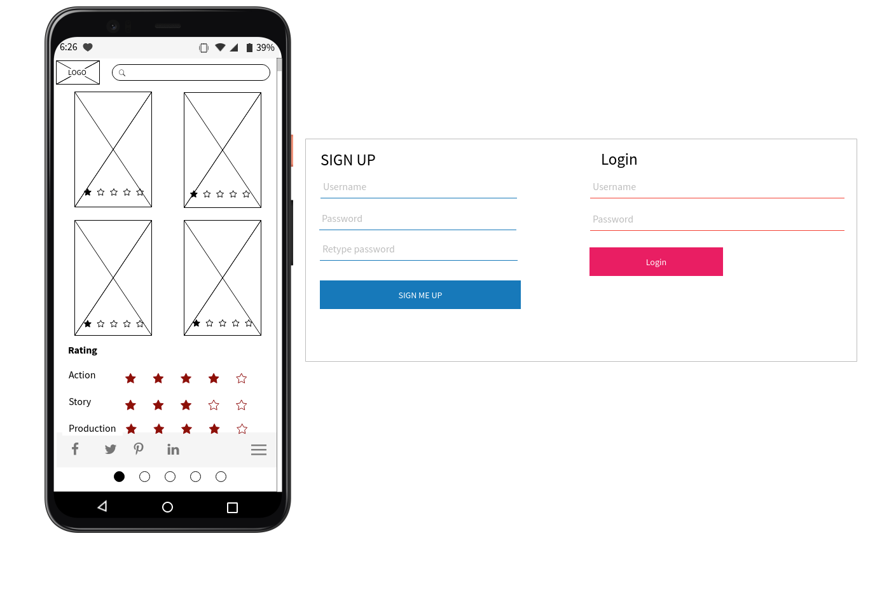  
Deliverable Links:  
[Mobile and Desktop UI(Home Page)](https://wireframepro.mockflow.com/view/M0006ce8ccef05532545fcb9a461a8a501617330448777#/page/D4a3974a573f7a68973d8c64db40da1d0)